**Worksheet-3.2**

**Student Name:-** Pushpraj Roy **UID:-** 20BCS9866

**Branch:-** BE- CSE **Section/Group:-** WM_617 “A”

**Subjetct Code:-** 20CSP-317 **Semester:-** 5th

**Subject Name:-** Machine Learning Lab

1. **Aim/Overview of the practical:-**

Implement Principle Component Analysis.

1. **Task to be done/ Which logistics used:-**

Principle Component Analysis.

1. **Steps for experiment/practical/Code:-**

import numpy as np

def PCA(X , num_components):

#Step-1

X_meaned = X - np.mean(X , axis = 0)

#Step-2

cov_mat = np.cov(X_meaned , rowvar = False)

#Step-3

eigen_values , eigen_vectors = np.linalg.eigh(cov_mat)

#Step-4

sorted_index = np.argsort(eigen_values)[::-1]

sorted_eigenvalue = eigen_values[sorted_index]

sorted_eigenvectors = eigen_vectors[:,sorted_index]

#Step-5

eigenvector_subset = sorted_eigenvectors[:,0:num_components]

#Step-6

X_reduced = np.dot(eigenvector_subset.transpose() , X_meaned.transpose() ).transpose()

return X_reduced

import pandas as pd

#Get the IRIS dataset

url = "https://archive.ics.uci.edu/ml/machine-learning-databases/iris/iris.data"

data = pd.read_csv(url, names=['sepal length','sepal width','petal length','petal width','target'])

#prepare the data

x = data.iloc[:,0:4]

#prepare the target

target = data.iloc[:,4]

#Applying it to PCA function

mat_reduced = PCA(x , 2)

#Creating a Pandas DataFrame of reduced Dataset

principal_df = pd.DataFrame(mat_reduced , columns = ['PC1','PC2'])

#Concat it with target variable to create a complete Dataset

principal_df = pd.concat([principal_df , pd.DataFrame(target)] , axis = 1)

import seaborn as sb

import matplotlib.pyplot as plt

plt.figure(figsize = (6,6))

sb.scatterplot(data = principal_df , x = 'PC1',y = 'PC2' , hue = 'target' , s = 60 , palette= 'icefire')

1. **Result/Output/Writing Summary:-**

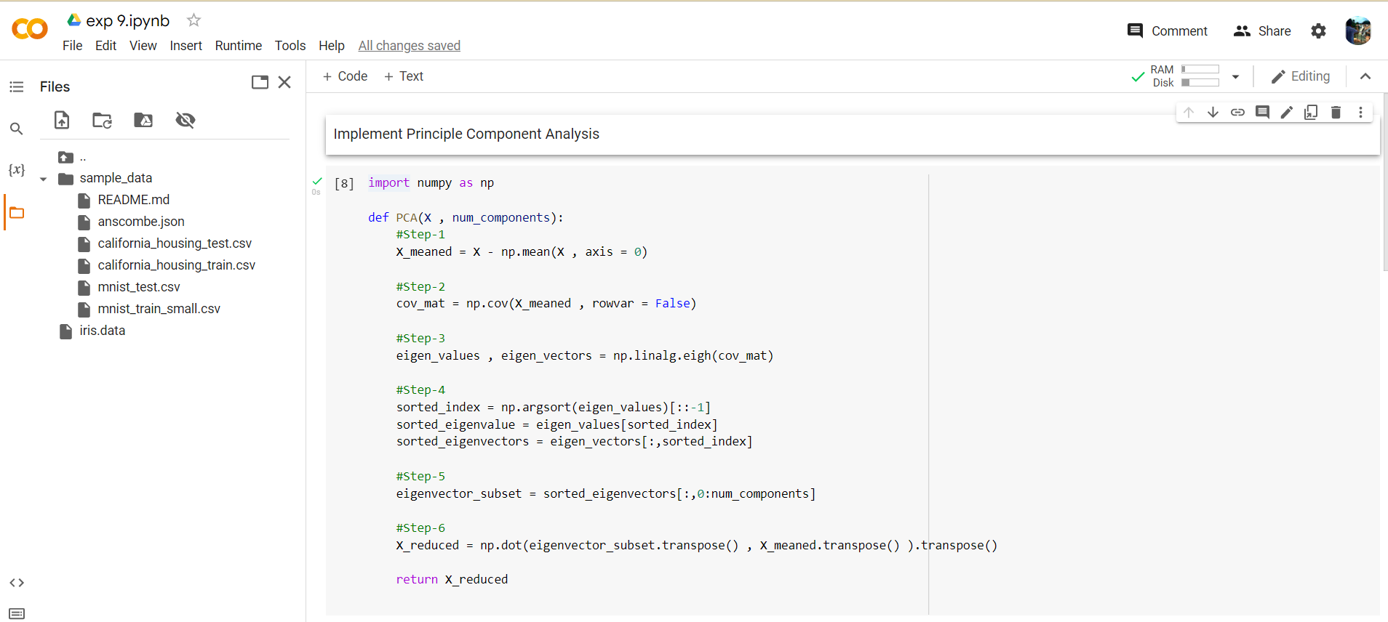

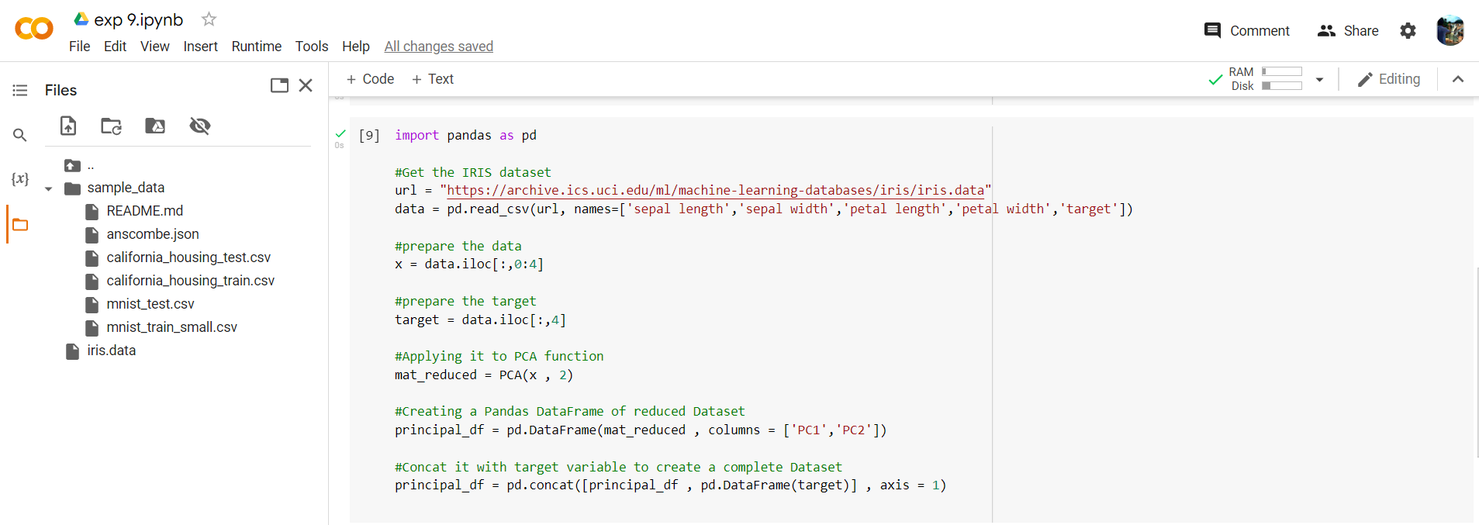

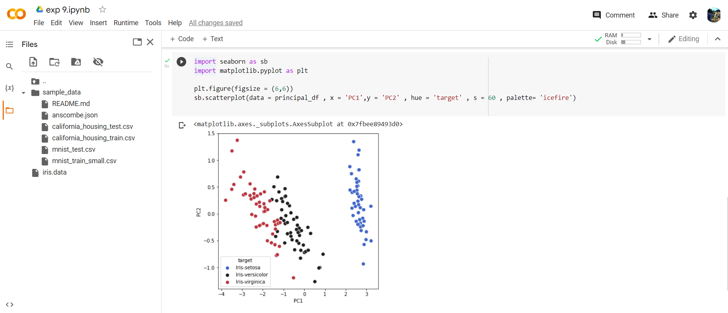

1. **Learning outcomes (What I have learnt):**

* Understood the concept of PCA.
* Learnt how to Covariance Matrix.
* Learnt the separation of eigen value and eigen vectors from CM.
* Plot the graph using seaborn and matplotlib.